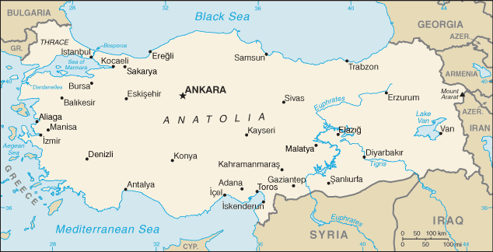
Turkey MAP

(TURKEY MAP.ewk.hu)

